**Chapter 6: Mathematical Materials.**

1. **Introduction**

Materials dominate our lives. The clothes that we wear, the tools that we use, the cars that we drive, the aeroplanes that we fly in, and the houses that we live in are all made up of materials. See [1] for an excellent summary of the many materials that we make use of in our lives. Modern electronics would not be possible without the development of semi-conducting materials, display screens rely on recent advances in liquid crystals, and the development of the jet engine happened at the same time as the invention of modern heat resistant alloys. Our history has even been defined in terms of the materials that we use, from the stone age, to the bronze age to the iron age, and now the computer age. Maybe the age that we live in should now be called the *composite age*. In the past materials were either natural, such as wood and stone, or evolved through many years of experience, such as glass or paper. The properties of these materials were either beyond our control, or were obtained through experiment or even good luck. However, with our modern understanding of physics and chemistry, this has all changed. In particular we can now design meta-materials with given mechanical, electrical, optical, thermal and other properties. Indeed, modern materials are often composites of different materials with very different properties arranged in a complex manner. The resulting behaviour of these materials often *emerges* from the way that these properties interact. These are called meta-materials, which are purpose designed to have special types of behaviour. The tool that we have to make sense of this complexity, and to design the materials that we need for the modern world, is mathematics.

In this chapter we will start by looking at how materials bend and deform under pressure. This is very important in engineering. For example it is essential that they know how strong the materials in a bridge or a building are, if what they build is going to stand up to the stresses and strains that it will encounter in its working life. We will start by looking at beams and we will see how mathematical models can help us to predict the behavior of that most ancient material, rock. We will then go on a journey through a series of materials, including the possibility of making the invisibility cloak worn by Harry Potter. Finally, as a bit of light relief, we will have some fun with the modern mathematics of paper and origami.

1. **How materials bend**



***Figure 1.*** *The modern portrait of Robert Hooke which hangs in Gresham College. You can see that he is holding a spring in his left hand.*

Perhaps the earliest materials that our ancestors made use of were wood and stone. Wooden tools don’t survive for long, but there are examples of stone tools which are believed to be over one million years old. Rock is itself a very interesting material, and its use for tools and then later for building, has shaped human civilization. Indeed we might say that rock is our longest lasting material. When we look at a rock we see something very solid. Indeed this is its main property as a material. However, appearances can be deceiving, and rock has many other properties. Some of these are very obvious too us all. Anyone who has been in an earthquake will have experienced the fact that rock can behave elastically. An elastic medium is one which can be distorted a small amount by a (suitably large) force, with a displacement proportional to the force. Crucially, when the force is removed, an elastic medium returns to its original position. An example of an elastic medium is a wire or a spring. The relationship between the extension of a spring and the force on it was, splendidly, first discovered by a predecessor of mine as Gresham Professor of Geometry. The amazing polymath Robert Hooke (1635-1704). His portrait (or at least a picture of what we think that he looked like) hangs in Gresham College in Barnard’s Inn Hall and is illustrated above. In this picture we can see that he is holding a spring in his left hand. It was his work on the elastic properties of springs, summarized by Hooke’s law, which likes at the heart our understanding of how materials bend.

One feature of an elastic material is that they admit elastic waves of expansion and compression. In a spring we can see this by sending a pulse along its length. In just the same way rocks admit waves and we see these in the shock waves associated with earthquakes. As well as being destructive these wave can also be very useful. Indeed much of our knowledge of the Earth’s interior comes from studying the way in which these waves are reflected, refracted and a diffracted through the rock. By solving an inverse problem (this is a problem in which we try to find the cause of a measured effect) we can then find out the properties of the Earth’s core. From a mathematical point of view this involves solving a *wave equation*. A very similar idea is used by oil companies to prospect for oil. To do this they detonate a small explosion (usually with compressed air) and measure the strength of the reflected waves. This allows them to detect oil deposits deep under the sea bed. As we saw in Chapter One this can be bad if you happen to be a passing whale.

The above observations show that over short time scales (which to a rock is anything up to about ten thousand years), a rock will behave elastically. However, over longer timescales rock can behave like a different type of material. We are used to seeing rocks as cold, hard and brittle. However, during the course of their existence, rocks can be both hot, under extreme pressure and (over sufficiently long periods) can flow almost like a liquid. This sort of behavior is called *viscous* and unlike an elastic material, in which displacement is proportional to force, a viscous material has a velocity, which is proportional to the applied force. Understanding all of these aspects of a rock as a material allows mathematics to applied to the fascinating question of understanding how rock layers buckle under the application of a large force and over long times. The reason that this is important is that under the effects of continental drift, rock layers are subjected to huge pressures from moving plates, and these forces deform the rock layers to produce mountains. Mathematical models can thus be used to predict how rocks fold and thus how mountains form.

We will now see if we can model how a rock layer deforms when it is subjected to a compression from a moving tectonic plate. We will follow our tried and tested modeling process to do this, starting with thinking about the basic processes involved. Our model will then progress through three stages of increasing sophistication.

A typical rock layer being deformed by a pressure P is illustrated below.

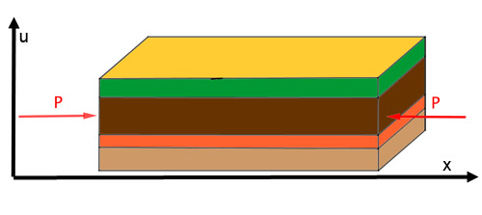

***Figure 2****. Layers of sedimentary rock being compressed with a pressure P.*

We can think of this layer as being like a very thick sheet of cardboard which is being pushed by a large continent which exerts a pressure P on the sheet. Try this yourself with a think sheet of card (paper won’t work as it is far too floppy). The card has a stiffness which means that it resists being bent. This is why a cardboard box retains its shape. However if you push the card hard enough (but not too hard) then it does bend. Release it and it should return to its original shape. This is called an *elastic* deformation If you push it really hard then the cardboard will crease and will not return to its original shape. This is called a *plastic* deformation. We can see both types of deformation occurring in cardboard, and we both occurring in rock. (Roughly speaking what is happening at a molecular level is that in an elastic deformation the bonds between the molecules in the material are stretched, whereas in a plastic deformation they get broken).

We will now follow our usual practice of building up a model for how the layer deflects by starting with a simple situation and making it progressively more complicated.

*Case 1. Bending a beam*

We start by thinking of the deflection of a beam of a beam of length L and which occupies the space 0 < x < L and has a vertical deflection given by u(x). Imagine that this beam has a *vertical load* per unit length given by q(x). Working out how this beam will deflect is a problem with obvious engineering applications when it comes to designing buildings. Both Leonardo da Vinci and Galileo studied it, but a (partial) solution had to wait till around 1750 and was due to Leonhard Euler and Daniel Bernoulli. They derived the differential equation (often called the *bending equation*) for u(x) which is given by:



Here I is related to the cross-sectional area of the beam, and E is the ‘Youngs Modulus’. The larger that E is the stiffer the material. So E is very small for paper, moderate for cardboard, and large for rock or steel.

What is special about this equation is that it is *fourth order* because it has a term which involves four differentials of u. This is unlike the earlier equation that we saw for the pendulum which was an example of a second order differential equation. The higher the order of the equation the more complicated its solutions tend to be (and the harder it is to solve).

The bending equation was used by Eifel to design the Eifel Tower in Paris! It is now very widely used by structural engineers to design many different types of building, made from widely different types of material. It can also be used by biologists to study bones, and even the workings of the human ear.

To see how this equation works, imagine that the beam is hanging under its own weight only. In this case q(x) = -ρg is a constant, where ρ is the density of the beam, and g is the acceleration due to gravity. It is negative because the weight of the beam acts to deflect it downwards. We then have



We can integrate this equation up four times to give



Here the values of a,b,c and d are unknown at this stage of the calculation. To find a unique solution we need four extra boundary conditions which describe how the beam is supported at each of its ends. This is quite a complex subject, and the answers depend upon whether the beam is free to move, firmly clamped, or supported on a hinge or a pin joint. One example is a beam which is clamped at the end at x = 0 and is free at the end x = L. In this case the boundary conditions are:

u(0) = ux(0) = 0 and uxx(L) = uxxx(L) = 0.

If we take a case in which L = 1 and ρg/24EI = 1, and apply these boundary conditions, then

u(x) = -x4 + 4 x3 – 6 x2

The deflection of the beam predicted by this model is illustrated below

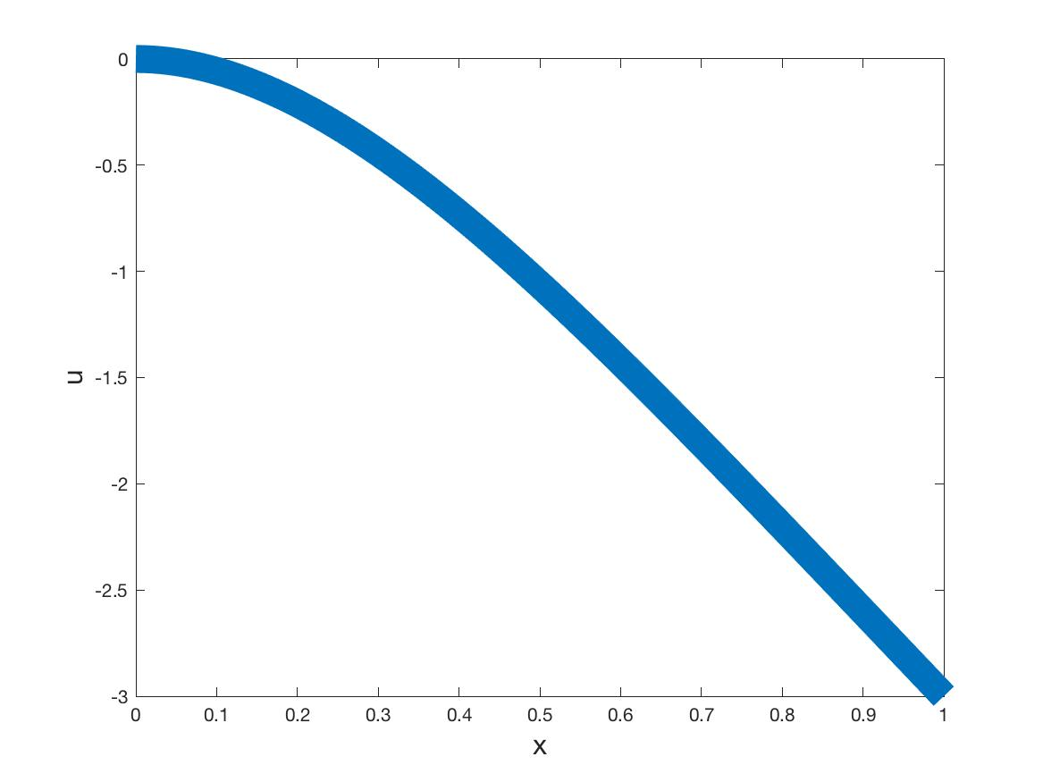

***Figure 3.*** *The deflection of a stiff beam under its own weight. In this figure the beam is clamped at the left end.*

*Case 2. Compressing cardboard*

Now, we go back to our experiment in which we try to compress a layer cardboard. In this case we supply a horizontal pressure force P. If we now extend our model to include this then we get a more complex fourth order differential equation given by



A special case of this problem is given by taking q(x) = 0 (which would correspond to having very light cardboard). We can then integrate the above equation twice to give



Here a and b are again arbitrary constants. If the boundary conditions at both ends of the cardboard are the same then we can take a = 0. We now have a second order differential equation which is in every way the same as the simplified equation for the pendulum that we looked at in Chapter One. This is the true power of applied mathematics. Quite different problems often lead to the same equation, and then the solution of one problem tells us the solution of the other. Using the results of Chapter One we can then write down the general solution which is given by



Here A and B are again unknown constants, which we need to work out from the boundary conditions at the end of the cardboard. There is a big difference between this solution and the earlier one for the beam. That is we have terms involving sine and cosine. This means that the deflection u(x) of the cardboard can have oscillations in x. But this is very reasonable. Imagine pushing a carpet. It is easy to have a ripple in the carpet, which gets worse the more we push it. Our model for the cardboard has predicted exactly this effect. A typical deflection of the cardboard layer is shown below. See if you can compress your layer of cardboard to look like this.

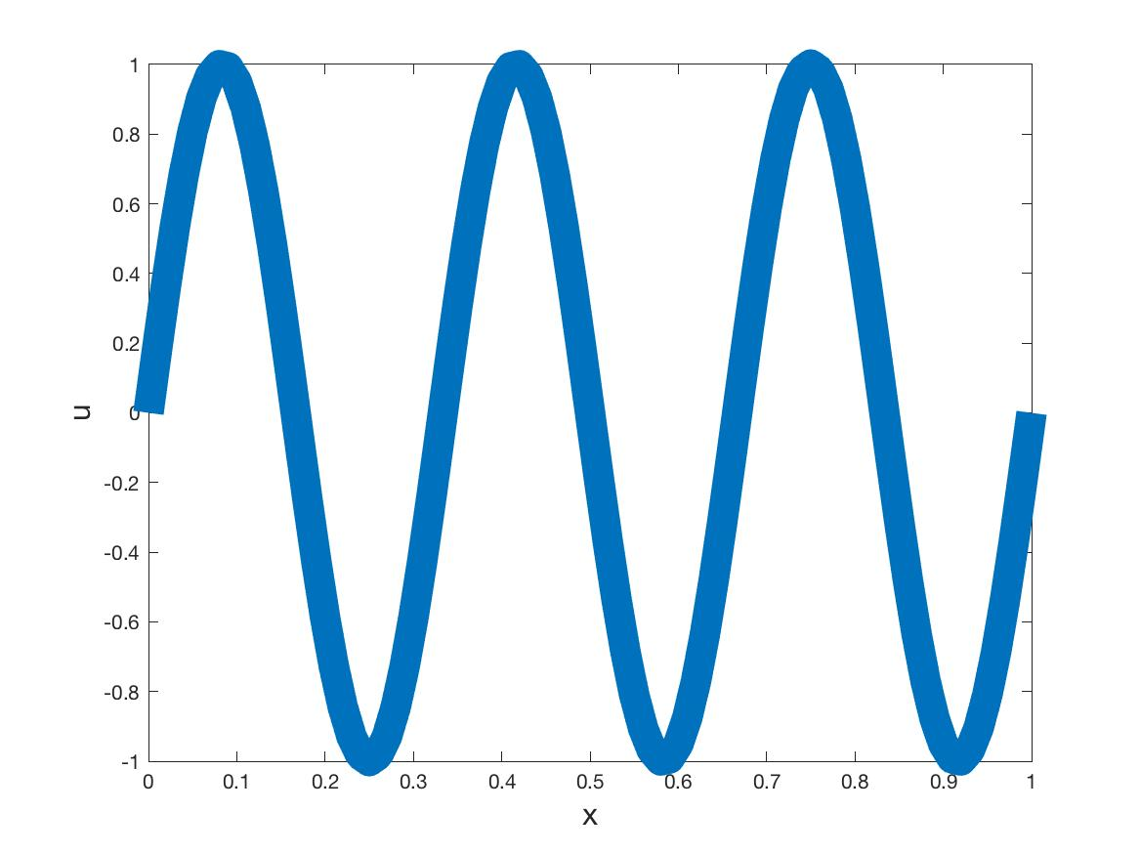

***Figure 4.***  *Ripples in a compressed layer of cardboard*

*Case 3. Compressing and bending rock*

Now we look at rock. In some ways a rock layer compressed from the side is like a cardboard layer, Whilst they might look very different, they are both stiff, and deform elastically in much the same way (just over very different time scales). However, there is one big difference. A rock layer is usually surrounded by other layers of rock. This is because sedimentary rocks are typically laid down at the bottom of the seam, with one layer formed on top of another over millions of years. When these are compressed by the forces of continental drift, then all of the rock layers buckle together. The effect of this is that the force q(x) in the expressions above now represents the force on the rock layer of all of the layers above and below it. To imagine what this is like simply go to bed. When you do this you will probably lie on a mattress. The mattress deforms to support you and to give you a good night’s sleep. To a rough approximation the rock above and below our rock layer acts in a similar way to the mattress. The force q(x) then represents how much the ‘mattress’ of rock is pushing on our layer of rock. Typically the more the rock layer deforms the greater this force is. It is difficult to give an exact description of this force as it depends a great deal on the type of rock. However at this stage we can use a device often used in modelling. If we don’t know something exactly, then we give a reasonable expression for it which involves some unknown parameters. We can then work out suitable values for these parameters later when we fit the model to the data (this process is called calibration). A typical such expression is to take

q(x) = -a u(x) - b u(x)2 – c u(x)3

where a, b and c are the parameters to be determined. Combining all of this together we finally arrive at our model for rock bending. This is given by the following fourth order differential equation:

latex-image-1.pdf

Having arrived at our mathematical model we will now try to solve it to find the shape of the rock. If you remember the rather similar looking equation for the pendulum, then we were unable to solve this in general because it was *nonlinear*. The same situation applies here. The nasty u2 and u3 terms put this equation beyond the reach of an analytical solution. But before we head for a computer to solve it for us, we recall that when we looked at the pendulum problem we could gain a lot of insight by considering small oscillations which satisfied a *linear* equation. In the case of the rock layer this linear equation is given by the following expression which is well known in the geo-sciences:



This equation looks rather formidable. But we can solve it using the complex numbers which proved so useful in Chapter 4. To do this we consider a solution u(x) which takes the form u(x) = eλx. Substituting this into the fourth order differential equation leads to the expression



If we divide by eλx then this equation is satisfied provided that λ satisfies the quartic equation



It is usually hard to solve quartic equations, but not in this case. This is because if we set μ = λ2 then we get the following quadratic equation for μ



We can now solve this quadratic equation by using the formula given in Chapter 4, so that there are two roots given by:



Now one of two things can happen. If P2 > 4a EI (so that there is a lot of pressure acting as we might expect if the pressure comes from continental drift) then both of the roots of the quadratic are real and negative. In contrast if P2 < 4a EI, so there is less pressure, then the roots are complex and are given by



Our modelling assumption is that the rock is being compressed by continental drift which leads to a very large (indeed almost infinite) pressure acting on the rock. In this case we have μ taking two negative values. Now as μ = λ2 then we must take te square root of these two negative values to give for possible values of λ, all of which will be purely imaginary. This means that there are values α and β so that



As u(x) = eλx then substituting the values for λ and using Euler’s formulas for cos(x) and sin(x) which we met in Chapter 4, then we arrive at the solution



This is called a *quasiperiodic solution* because it is the sum of two periodic functions.

We saw a similar function when we looked at the solution of the forced pendulum. The graph of the solution is shown below, and certainly resembles the patterns seen in rock.

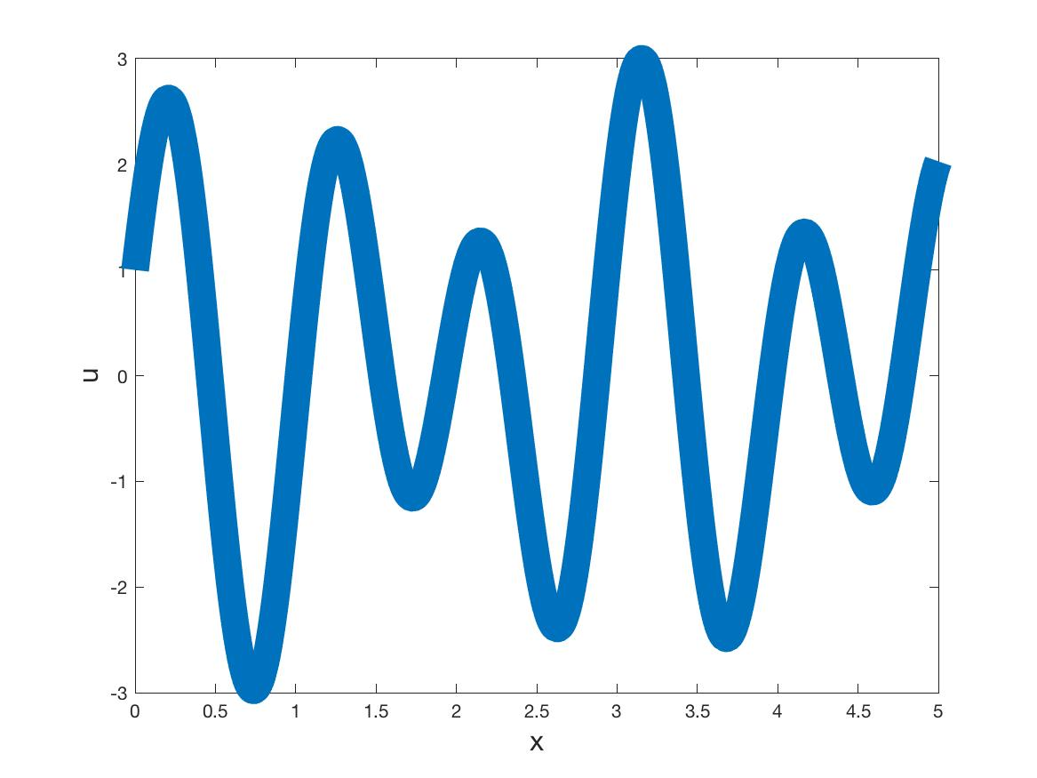

***Figure 5.***  *The quasiperiodic shape of rock deformed under a very high pressure.*

The picture of rock deforming in this way is often found in text books, and can often be found in rock layers. An example of such is given below, taken from a photo I took of small scale folds in rocks at Bude on the North West coast of Cornwall. (Rumour has it that my surname originated in Bude.)

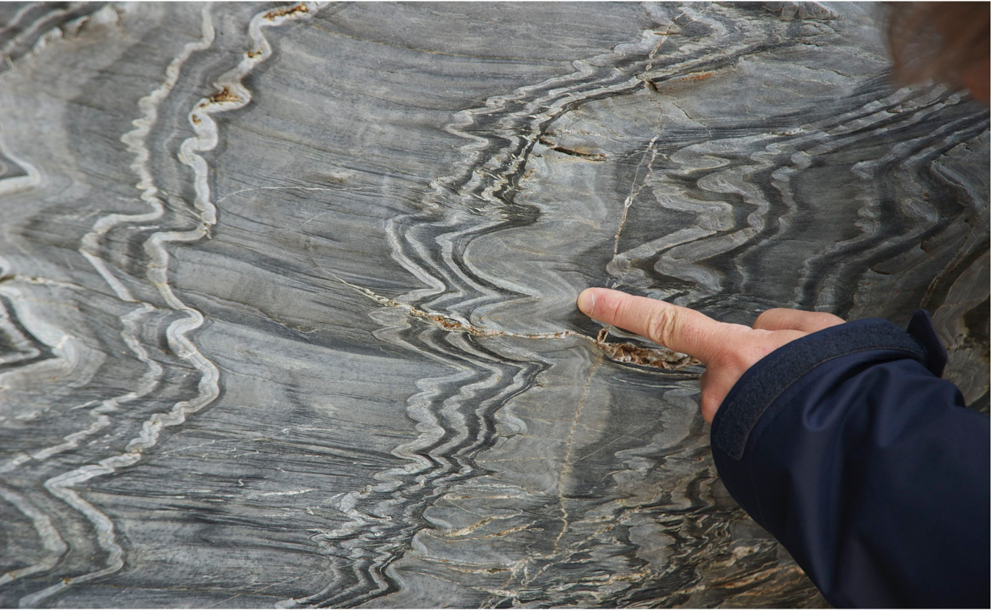

***Figure 6.*** *Quasi-periodic folds in rocks at Bude in Cornwall.*

However, quasi-periodic folding it is not the only shape that you find rocks deforming into. The reason for this is the action of the extra nonlinear terms in the model that we are looking at. These can lead to much more exotic folding patterns.

To check this we compared the results of our model predictions against an experiment. Now, we don’t have many sedimentary rocks at Bath, and certainly don’t have a device strong enough to compress a rock. However, thanks to a university reorganisation, and a change in the name of our department (it happens!) we did have a lot of redundant visiting cards. Stacking them in layers gave us a cardboard model of sedimentary rock layers. These we could then compress. This allowed us both to test the model above, and also to see how the layers of rock (sorry cardboard) interacted with each other. My very good friend Giles Hunt, Professor of structural engineering at the University of Bath, had a press strong enough to compress these layers and was very keen to see the results. If you look below, then you can see the results of our efforts. They key thing to see is that we don’t get the simple sine-waves of rock folding patterns often illustrated in text books. Instead we get folds which are like zig-zags. They have patterns which are a combinations of straight straight sections joined together by sharp bends. Geologists call these kink bands and chevrons.

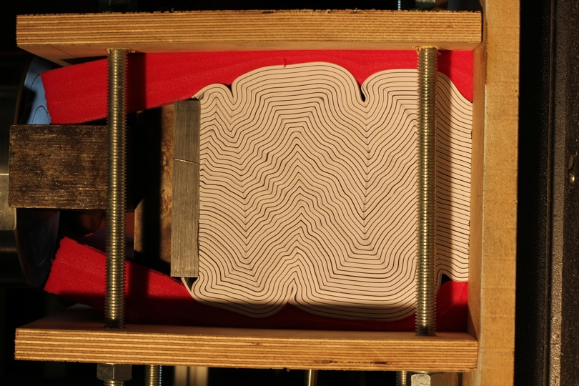

***Figure 7.*** *Compressing layers of cardboard. The bar on the left is applying a horizontal pressure. The layers are forced together by stiff foam on the top and on the bottom. You can see the elegant zig-zag patterns with a small quasi-periodic ripple as well.*

So far we have used a differential equation model to predict the folding patterns of rocks and other materials. But there is an elegant *geometrical* explanation of why we get these zig-zag patterns. Rocks typically get folded when they are deep underground and there is a lot of pressure both vertically and horizontally on the layers. The vertical pressures force the rock layers to fit together (just as in the experiments above). So the layers can only deform into shapes which fit together. It is a geometrical fact that sine-waves do not sit one on top of each other. However zig-zag shapes do. Try this yourself with some sheets of cardboard. So if you want to stack a lot of similar shapes one on top of the other then only a zig-zag shape will do.

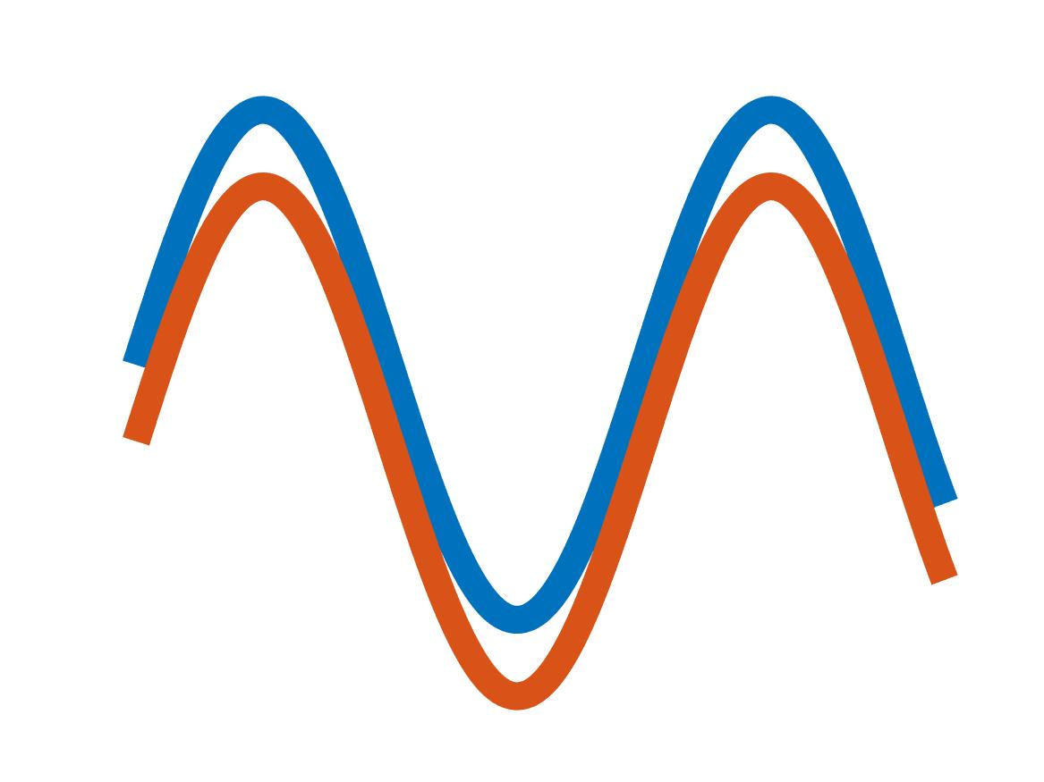

***Figure 8.*** *One sine wave does not fit on top of another without creating a void.*

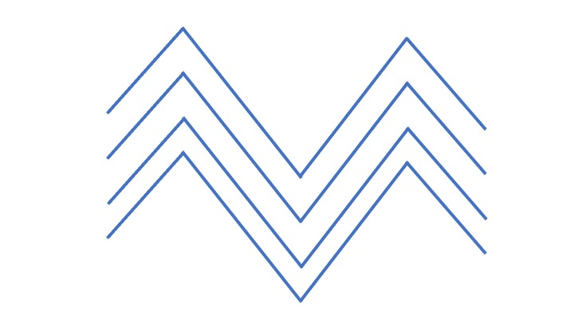

***Figure 9.***  *However Zig-Zag shapes can easily stack together without creating voids.*

So, do rocks deform in the same way was paper. Very much so! Here is a lovely example of rocks folded into chevron patterns at Millock Haven in Cornwall with a scale provided by a human at the bottom of the cliff. You can clearly see the zig-zag structure, with the layers fitting together perfectly. As an example of a mathematical shape which can be seen in nature these folded rocks are hard to beat. These are very well worth a visit.

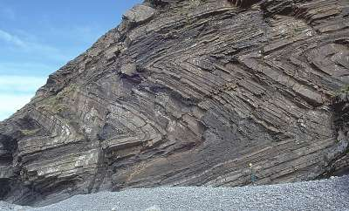

***Figure 10.***  *Chevron folding patterns at Millock Haven, Cornwall.*

If you look at the paper folding examples you will see that there are occasional gaps, or *voids*, in the layers. Typically these are at the sharp corners in the folds. This is because it takes a very large force to bend rock into a sharp corner. If the horizontal force is not large enough then instead of a sharp corner the rock has a slightly more gentle bend, and the rocks don’t quite fit on top of each other, leading to a void. Here is an example, again from the rocks in Cornwall.

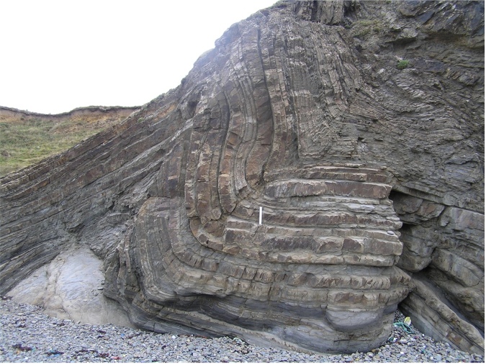

***Figure 11.*** *Voiding patterns in the rocks in Cornwall.*

Using the mathematical model above, we can precisely predict where these voids will occur. Why should we care? Well voids occur in real rock folding, and it is in the voids that minerals get deposited by water running through the rocks. One of these minerals is gold. So mathematics can help in a geological treasure hunt by locating where we might find gold in folded rock layers.. Maybe this might make us all rich! More about rock folding can be found in [2].

**3. Let there be light: photonic crystals**

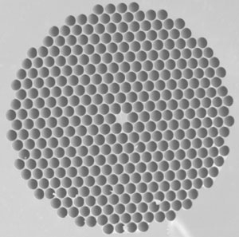

***Figure 12.*** *A photonic crystal*

Having seen how materials bend, we will now use mathematical models to help us to understand more about their inner workings.

Many materials are made either directly, or indirectly, from rock. Obvious examples we see all around us in construction include lime and gypsum and concrete. The latter material was invented by the Romans and allowed them to build many of their extraordinary pieces of engineering, including docks and aqueducts. Rocks are also closely linked to materials used in communication. It was discovered in the early part of the twentieth century that crystals could be used in radio communication, both to detect signals imposed on radio waves (in the celebrated crystal sets which I used to build) and then to fix the frequency of the same waves. The same technology is used in digital watches to give a highly accurate time-piece. More recently crystals and glass are used in fibre optic technology. It is likely that if you have broadband that for part of its path, the broadband signal is transmitted along a fibre-optic cable. It is a simple fact that light going down such a cable can not only convey much more information, but can also be transmitted without a lot of loss of signal. This observation led the designers of fibre-optic cables to think about whether it as possible to reduce the attenuation of the signal still further. This would allow very long distance communication with out the need for units to boost the power. This is especially important for the transmission of signals under the ocean. This problem has been solved with the use of some very fancy mathematics in the shape of *photonic crystals*. An example of such a crystal is shown above. As you can see the photonic crystal is made up of a fibre optic cable with a regular lattice of holes drilled into it. To study such crystals we set up the (partial differential) equations for light moving through glass. There are a number of such equations, including the Helmholtz equation and the nonlinear Schrodinger equation for example. The precise equation used depends upon the intensity of the laser light beam, and also the type of crystal used. The Helmholtz equation is the simplest of these, and if u is the intensity of the laser light then it satisfies the partial differential equation

$$u_{xx}+u_{yy}+u_{zz}+ ω^{2}u=0,$$

where $ω$ is the frequency of the wave. When this equation is solved to find u for the above geometry, it is found that at certain frequencies, the holes in the crystal act as miniature resonant cavities. These resonant cavities act effectively to block the light beam going through the middle of the crystal to leak out through the sides. More details of this can be found in [3].

The effect is an effectively loss free cable (provided that it can be manufactured in the first place). Fortunately this is now possible. The picture above shows an example of just such a photonic crystal. As you can see it is a very complex shape, and until fairly recently it was thought impossible to analyse the behaviour of light in such a crystal without the use of huge, and expensive, computing power. However advances in manufacturing have gone hand in hand with advances in mathematics. Indeed it is because of the development of new mathematical techniques that we are not only able to analyses these complex shapes, but we can also predict their optical performance with some precision. The new mathematical techniques are called multi-scale homogenisation methods and they work by recognising that a material such as a photonic crystal has several scales. It has a micro-scale which is the wavelength of light, an intermediate meso-scale which is the scale of the holes, and a macro-scale which is the width of the whole crystal. (Many other materials have several scales, two natural examples are wood, bone and cells). The material behaves differently at these different scales, and its properties result from the way in which these different behaviours interact. Multi-scale mathematical methods allow us to do this, and thus predict the behaviour of the photonic crystals without the need of a super computer. Multi-scale methods now have many more applications, ranging from weather forecasting to structural optimisation.

1. **Going liquid**

At school we are told that materials are, either liquids, solids or gases. This is not strictly true. Depending upon the arrangement of their molecules, there are many materials, which are in an intermediate state between being a solid and a liquid. An important example of such an intermediate state, are *liquid crystals*, and these materials play a vital role in modern technology. In the figure below you can see the different arrangements of molecules as we pass from a liquid to a solid, with two forms of liquid crystal, Nematic and Lamellar in between.

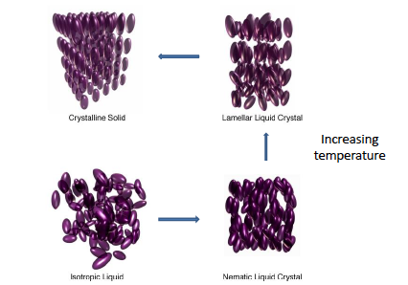

The key feature of a liquid crystal is that its molecules are long and thin, and they have a *preferred direction*. These materials are called *anisotropic*, and are very different from an *isotropic* liquid which has no preferred direction. Their properties can all be determined by mathematical arguments [4]. What makes nematic liquid crystals useful in technology is that the direction of the molecules can be changed by an electrical or a magnetic field, and this change can alter its conductivity, viscosity, compressibility and, crucially, its refractive index. The latter property gives them huge applications in liquid crystal displays (LCDs) which can be found in computer screens and nearly every other type of display medium. (Possibly the first example of such being the screens used in early digital watches.) Nematic liquid crystals are also used in optical switches, sensors and elastomers (a visco-elastic polymer). Mathematical models are hugely important in the design of LCD devices. In particular in the recent development of *bi-stable displays* which require no energy to display information, only to change it. The mathematical approach to such a design is to find a formula describing the energy of the liquid crystal state and then proving rigorously that this energetic state has two stable configurations. This takes us into the realm of partial differential equations and we meet these again in the next section.

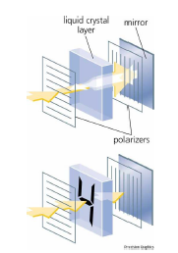

1. **Crystals and separating phases.**

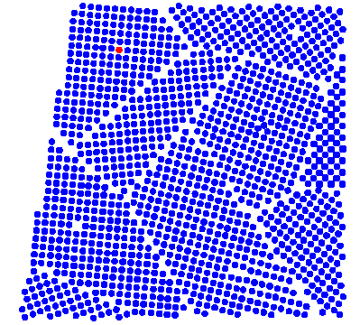

***Figure ???*** *An example of the molecules in a polycrystalline material showing both regular crystalline patterns, and the phase boundaries between the regular regions.*

We have so far met photonic crystals and liquid crystals. Most engineered materials, including metals and ceramics are in fact polycrystalline. An example of a polycrystal is illustrated above Polycrystaline materials are composed of many small crystalline grains which are separated by boundaries. If, for example, a piece of metal is heated in a furnace, the average size of the metal grains grows. The small grains will disappear, while the big ones will grow, due to changes in the boundaries between individual grains. Exactly the same mathematics can be used to describe this process as describes the evolution of froth on a pint of beer, which we looked at in the last lecture. This raises the important question of whether we can design new materials by predicting the shape of the poly crystals.

Crystals themselves have a strong link to mathematics, with their shape, symmetry, size and strength highly predictable by mathematical methods. A recent example of this is the celebrated ‘Bucky ball’, which is a form of Carbon, in which 60 Carbon atoms are arranged geometrically in the shape of a soccer ball made of twenty hexagons and twelve pentagons, shown below.

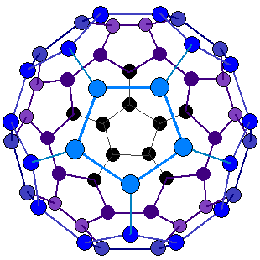

***Figure ???*** *The structure of the Carbon atoms in a bucky-ball. This is the same pattern as in a traditional soccer ball.*

Mathematicians call this shape *a truncated icosahedron.* Crystals take such symmetric shapes, not because they are particularly beautiful (although of course they are) but because they represent minimal energy states for the molecules. This makes them both strong and stable. We saw some lovely examples of these in Chapter One in the form of snowflakes.

Understanding energy turns out to be the key to looking at many different types of material, including the liquid crystals that we looked at in the previous section. The process of doing this mathematically is to find a formula for the energy and to then find the configurations of the material that minimise this energy. This simple idea is the key behind unlocking the secrets of many materials and allows us to predict many varied and exotic shapes of those materials. One example of this is a two-phase material, such as a cooling metal, which can form exotic patterns such as the one illustrated on the right. It is possible to describe, understand, predict, classify and control these patterns. One such model for pattern formation in a two-phase material the celebrated *Cahn-Hilliard equation*:

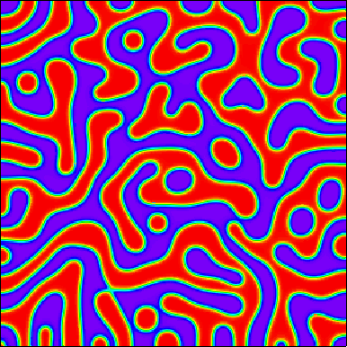



FOUTRT ORDER

In this partial differential equation c takes the values of +1 and -1 in each of the two phases, and the expression describes how the phases evolve in time and in space to give the shapes above. The Cahn–Hilliard equation has applications in polymer science, complex fluids and many other industrial applications) and is a major tool in allowing mathematicians to predict the behaviour and form of complex materials which are binary mixtures of two other materials.

1. **Granular materials and the brazil nut effect**

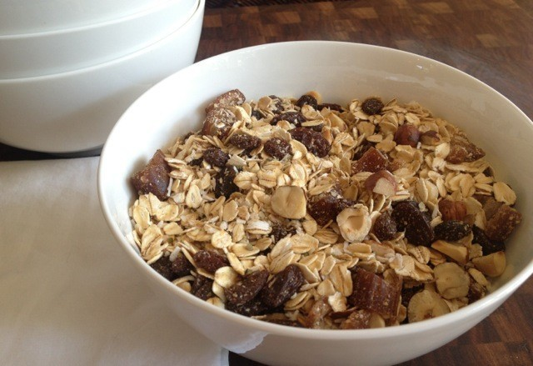

It is time for breakfast and you reach for your packet of cereal, which is a mix of muesli and nuts. As you pour the cereal into your breakfast bowl you find, much to your surprise, that you get a bowl full of nuts. This is odd, because that it means that the large nuts have risen to the top of the muesli. This seems to contradict our intuition that larger objects should go to the bottom. What you have seen (literally) is an example of the Brazil Nut Effect. The reason for this is that your cereal packet comes to you having travelled a considerable distance. (To learn more about the movement of food around the world have a look at last month’s lecture.) During its travels it gets shaken up. It is the shaking which is the key to the Brazil Nut Effect. As the cereal is shaken the nuts may move up a little, leaving gaps beneath them. The smaller and faster moving muesli then flows into these gaps. As it does so, so the nuts rise upwards. Eventually they get to the top of the cereal.

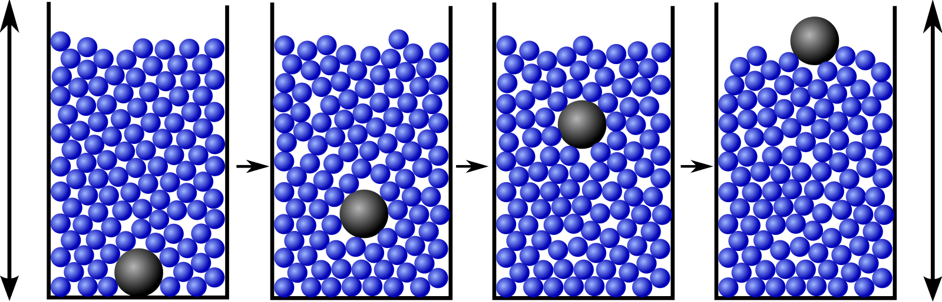

The Brazil Nut Effect is just one of the counter intuitive properties shared by granular materials, which as the name suggests are materials made up of grains. Granular materials are very important in the food industry. For example they make up the grain in grain silos, the are the basis of baby food, nuts, rice, coffee, chocolate, custard powder and many cereals such as cornflakes. Granular materials also occur naturally, with snow in large quantities being a good example, and sand another. Many of the fascinating patterns seen in sand dunes are a consequence of it being a granular material [5]. Another application of granular materials is in the manufacture and storage of paint powders, fertilizer, cement and even sand. Mathematics is used to predict how granular materials can flow. In some sense, granular materials do not constitute a single phase of matter, but have characteristics similar to solids, liquids or gases, depending on the average energy per grain. However, in each of these states granular materials also exhibit properties which are unique. Indeed, granular materials also exhibit a wide range of pattern forming behaviours when excited (e.g. vibrated as above, or allowed to flow). Different behaviours arise depending upon whether the grains can move freely over each other, or if they can get jammed. The latter is certainly what you don’t want in a grain silo. As such granular materials under excitation can be thought of as an example of a complex system, and we will meet these again in section 8. Mathematics plays a critical role in predicting whether jamming will or will not occur, and by doing this helps to feed the world.

**7. Harry Potter’s cloak**

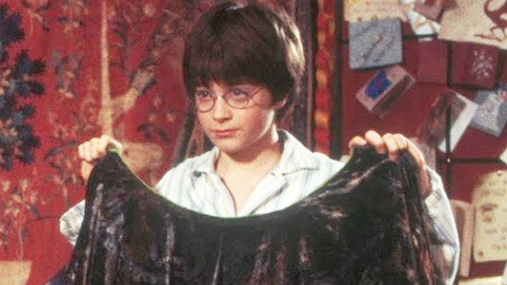

Many of us will have watched Harry Potter films, or maybe are fans of Star Trek. Both of these contain devices for making you invisible. In the case of Harry Potter a special cloak, and for Star Trek the infamous Cloaking Device [6]. Once thought just to be the product of the imagination, the modern science of meta-materials is coming closer to the invention of a true invisibility cloak, that can render the wearer invisible when they are watch from several different directions. Early invisibility devices used a combination of lenses and mirrors to bend the light around an object to make it appear invisible. Making these required a knowledge of geometrical optics, and in particular the mathematics of angles and trigonometry.



***Figure ????*** *An arrangement of mirrors which would render the potato in the middle invisible.*

However these methods of cloaking could only work from one direction. There has been intensive research into finding materials which can cloak someone from many directions. Researchers in the US have now invented a digital cloaking device that works from many different directions, and despite some short-comings suggests such technology may be closer to practical uses in the real world than you might think. This system calculates the direction and position of the light rays so they can be properly displayed as if they were unobstructed. As a result, the area behind the display is effectively cloaked. As the viewpoint shifts, the image on the display changes accordingly, keeping it aligned with the background. Invisibility cloaks themselves rely on meta-materials, which as we described in the introduction, are a class of material engineered to produce properties that don’t occur naturally. Light is electromagnetic radiation, made up of vibrations of electric and magnetic fields. Natural materials usually only affect the electric component, but meta-materials can affect the magnetic component too, expanding the range of interactions that are possible. The meta-materials used in attempts to make invisibility cloaks are made up of a lattice with the spacing between elements less than the wavelength of the light, which can then be bent by the material.

A related development has been the design of clothing which is not only flexible to fit the body, but also has the properties of the LCD screens described above. By using these materials we can envisage a future where the colour of a dress or a suit can be instantly changed to meet the needs of an event, and can even display moving writing if a sponsor desires it. Maths meets fashion indeed.

**8. Getting electrical**

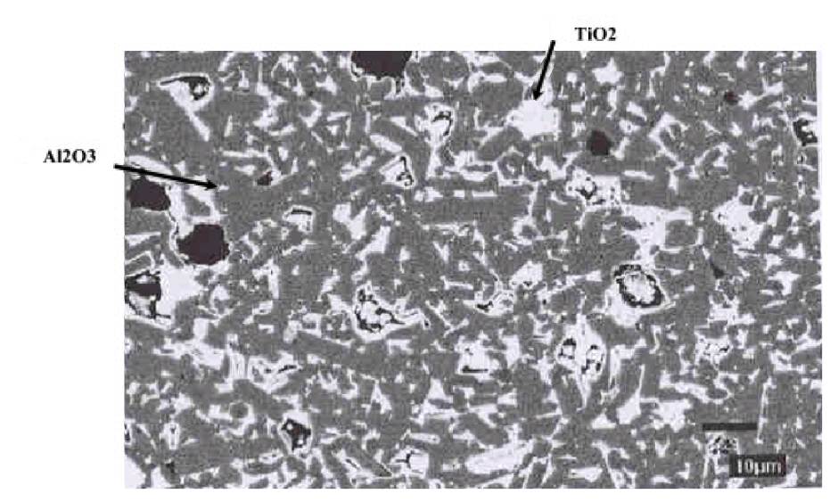

***Figure ????*** *A composite material made up of Aluminium Oxide and Titanium Oxide. These two materials have very different electrical properties which combine to give an emergent electrical behaviour of the composite material.*

Suppose that you want to construct a building at an airport. If that building reflects radar waves then you have a problem. The radar at the airport, or in the aircraft landing or taking off there, will reflect off the building at all sorts of angles. The result is that the radar system gets confused and the radar displays get cluttered. Therefore it is a good idea to cover buildings with a material that absorbs the radar waves. The same principle applies if you want to make a stealth aircraft invisible to radar (rather like the Harry Potter cloak). During the Second World War it turned out that nature had already solved this problem. The famous de Havilland Mosquito was made of wood, and this made it almost invisible to the German radar systems. Now, the challenge is to make a synthetic material with the same radar absorbing properties. To do this we make use of the new ideas of *complexity* and of *emergent properties*. Loosely speaking, a complex material is something which is made up of many different materials. An example of such is a composite material such as carbon fibre, which is used in many different applications, from aircraft engines to fishing rods. The key feature of such a complex material is that its properties are much more than the sum of the different component properties. Instead they reflect the way that these different properties *interact.* Or more poetically, the whole is greater than the sum of the parts. Such properties are then said to *emerge* from the interactions, and may be very different from the original properties of the component materials. The only way to find out what these emergent properties are is to use quite sophisticated mathematics.

The question of designing such a radar absorbing material came to our team at Bath, and it was decided to make a complex meta-material combining the different electrical properties of Aluminium Oxide and Titanium Oxide. On the technical side, one of these behaves like a resistor, and the other like a capacitor. Resistors have electrical properties, which are independent of the frequency of the electrical waves, which pass through them. In contrast, capacitors conduct electricity well at high frequencies, and badly at low frequencies. To create the complex material we took a random mixture of these two different materials mixed in careful proportion. You can see a picture of the resulting mixture here. As you can see it is very complex, and hard to analyse, even using the multi-scale methods described above. Instead it is possible to use a branch of mathematics called *random matrix theory* to study them. The material above can be modelled by a network of resistors and capacitors, see below.



***Figure ???*** *A random network of resistors and capacitors which models the electrical behaviour of the composite material.*

Now we use a trick often employed in studying complex problems. Instead of trying to exactly reproduce the parts of the material we instead consider them to be randomly placed according to certain statistical rules. We then look at the statistics of the electrical properties of resulting network, in particular its conductivity. The network of resistors and capacitors itself can be represented by a matrix with random coefficients, and its statistical properties found by the theory of such random matrices. This turns out to be a very powerful technique for predicting the properties of the original material and gives excellent results. (We use the same idea of representing complex processes by random variables in many other applications, including studies of the behaviour of the stock market and the movement of crowds of people.) Below you can see the result of our efforts. On the right is the conductivity of the material as a function of frequency, and on the right the paths of the current through the network at the frequency indicated by the arrow.

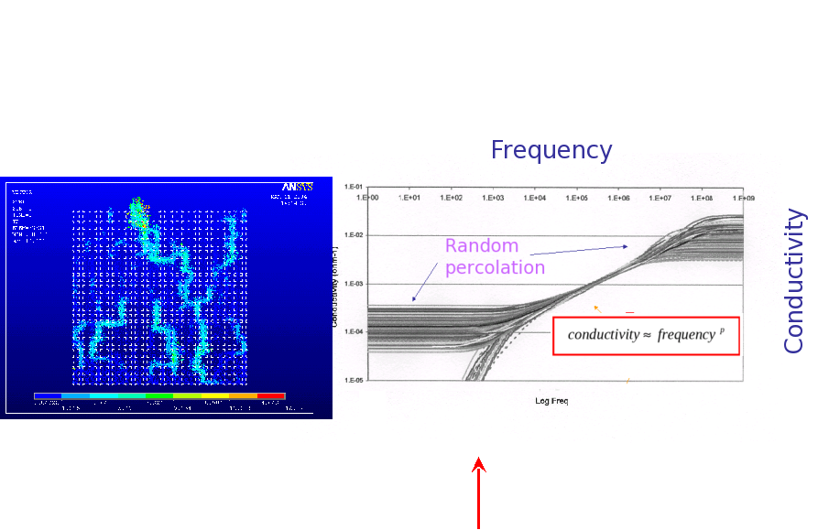

These results agree very well with experiment. Random matrix methods are now finding many other applications to the design of many other complex materials [7].

1. **Paper and Origami**

11

One of my favourite materials is the humble sheet of paper. Perhaps because it is so commonplace and ordinary that we forget that the invention of paper by the Chinese has possibly had the biggest effect on human civilisation of all materials. The invention of paper allowed both the rapid transmission of ideas, and the ability to store knowledge for future generations. It has been around for a lot longer than modern electronic storage media, and has the advantage that words written on paper can be read many years later, whereas there is no guarantee that a particular electronic means of storing data will still be usable fifty, or even ten, years into the future. (Who still uses floppy discs for example). Paper is typically made from wood pulp which is added to boiling water and then laid out in large sheets and left to dry.

ADD MORE G+HR^YRD

Mathematics is certainly important in regulating the heat and drying process for making paper, but it really comes into its own when it comes to designing the final shape of the paper that we use. In recent years most countries (apart from those in North America) have adopted the A0, A1, A2, A3, A4, A5, … standards for the shape of the paper that they use. These **all** have the same, carefully chosen, proportions illustrated above. If you take a sheet of A0 paper and fold it in half along its longest side, then you get A1, fold this in half and you get A2, then A3, then A4 etc. The sheet of A0 paper has area of exactly 1 m2 , so the area of A1 is ½ m2 and A4 is 1/16 m2. However, every such sheet of paper has *exactly the same shape.*

One very nice feature of this sequence of paper sizes is the way that they fit together. If you take the sheets A1, A2, A3, A4, A5, A6, A7, A8 etc and find their combined areas then you get the series

½ + ¼ + 1/8 + 1/16 + 1/32 + 1/64 + 1/128 + 1/256 + …

This is an example of a geometrical series in which the ratio of the successive terms is ½. If we set

S = ½ + ¼ + 1/8 + 1/16 + 1/32 + 1/64 + 1/128 + 1/256 + …

Then, multiplying by 2 we get

2S = 1 + ½ + ¼ + 1/8 + 1/16 + 1/32 + 1/64 + 1/128 + 1/256 + …

It is clear from this calculation that

2S = S + 1

Hence we get

S = 1.

What this means is that ….

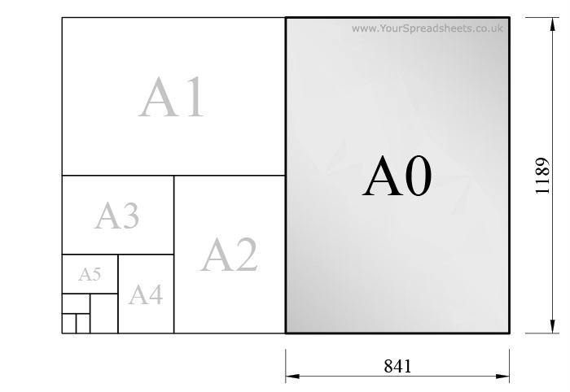

Only one shape of paper has this property, and this can be worked out mathematically. Suppose the proportions of A0 piece of paper are x:1 with x being the longest side, then those of the paper folded in half are 1:(x/2).

**Draw the picture**

Thus, x must satisfy the equation

$$\frac{x}{1}=\frac{1}{x/2}=\frac{2}{x}$$

Rearranging this equation gives $x^{2}=2$ so that

$x=\sqrt{2}=1.4142135623730950488….$

If you take a sheet of A4 paper, then its longest side is 29.7 cm and its shortest side is 21 cm, so its proportions are 1.41428:1 which is very close to the value above.

Once you have a sheet of paper it is natural to want to fold it. The Japanese have been doing this for centuries and have developed the wonderful art of Origami creating a huge variety of designs of animals, flowers, people and decorations, all folded from a single square sheet of paper, without any cutting. In recent years, mathematicians have become increasingly interested in origami. They ask the questions of what shapes can in theory be folded from a piece of paper, and also how these shapes can be created. Out of this study have come some incredible new origami designs, which are a true fusion of mathematics and art. One of the leading exponents of these new designs is Robert Lang, and both the theory and examples of his work can be found in [8]. Below you can see one of his designs, the Bull Moose. On the left is the origami creation and on the right is the set of folds on the square sheet of paper which lead to the moose design. Robert Lang also uses his origami skills to design the solar panels and radio antennae for satellites, which have to be unfolded once they get into space.

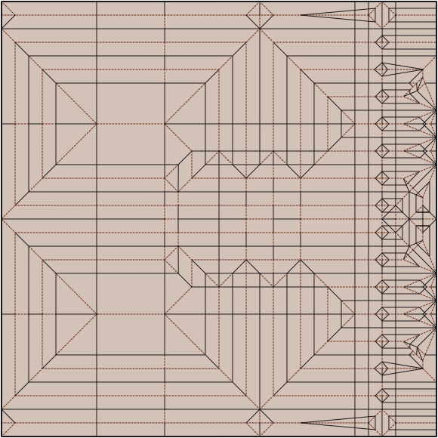

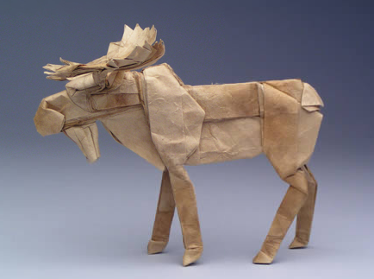

I challenge anyone, who sees these folding patterns not to say that mathematics is a true bridge between the arts and the sciences!

**10. References**

# [1] M. Miodownik, *Stuff Matters: The Strange Stories of the Marvellous Materials that Shape Our Man-made World,* (2014), Penguin.

# [2] J. Cosgrove and M Ameen, *Forced folding and Fracture*, (2000), Geological Society

[3] M. Richard, *Introduction to photonic crystals and band gaps*, (2008), Springer

[4] A. Majumdar, *The mathematics of liquid crystals*, (2012), OCCAM Preprint http://eprints.maths.ox.ac.uk/1550/1/finalOR49.pdf

[5] R.A. Bagnold, *The physics of blown sand and desert dunes*. (1941) London, Methuen.

[6] A nice description of the optics behind the Harry Potter cloak can be found in the article http://www.independent.co.uk/news/science/invisibility-cloak-rochester-cloak-digital-harry-potter-a7039106.html

[7] N J McCullen, D P Almond, C J Budd and G W Hunt ,*The robustness of the emergent scaling property of random RC network models of complex materials, (*2009 )  
[Journal of Physics D: Applied Physics](http://iopscience.iop.org/journal/0022-3727), [Volume 42](http://iopscience.iop.org/volume/0022-3727/42), [Number 6](http://iopscience.iop.org/issue/0022-3727/42/6)

# [8] R. Lang, *Origami Design Secrets: Mathematical Methods for an Ancient Art,* (2011), CRC Press